**EXPERIMENT 5**

**AIM: Working with Dockerfile to Build and Push Docker Image**

**Steps to Complete:**

1. Create following Dockerfile

FROM alpine

MAINTAINER SUDIPT

RUN apk update

RUN apk add nodejs

RUN mkdir /app

COPY index.js /app

WORKDIR /app

RUN node index.js

1. Now we have dockerized the app, we will Build image from Dockerfile.

docker build –t myimage:0.1 .

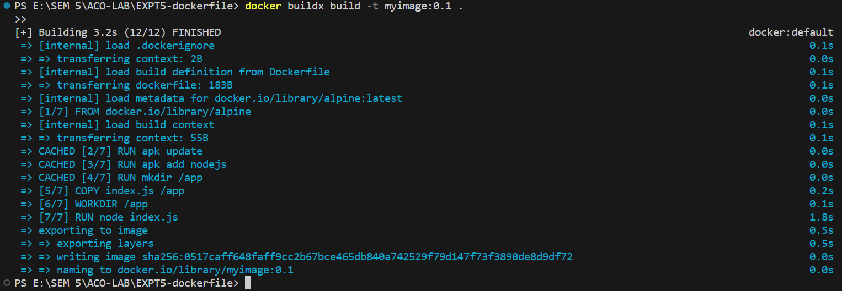

1. Create account on Dockerhub and create a repository in it.

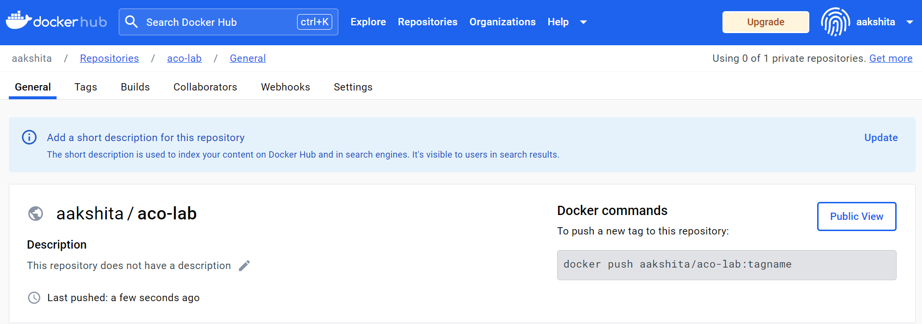

1. Tag the recently created image using following command.

docker tag imageID Repositoryname



1. Login to Dockerhub from console using following command.

docker Login



1. Now push the image on Dockerhub using following command.

docker push Repositoryname

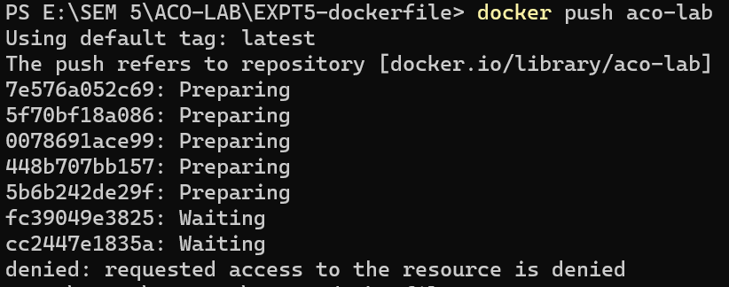

1. Pull and Run the container of your deployed image on docker hub.

Docker run -d image_name

